# JedisPutStep

**Objective:**

It is used to store the key value pairs in the redis server using Jedis client.

**Attributes:**

|  |  |
| --- | --- |
| **Attributes** | **Description** |
| value_type | To select type as free marker template or handlebar |
| data_type | To select which type of data need to enter. Ex: List, Set, HashMap and String. |
| key | To enter the ke nameTo select which type of data need to enter. Ex: List, Set, HashMap and String. |
| value_to_save | To enter the value for key |
| plugin_name | To connect with redis server based on the plugin credentials |

**Sample config.json:**

{

"workflows": [

{

"name": "jedis-put",

"id": 200,

"trigger": "rest",

"expression": "jedis-put",

"method": "GET",

"steps": [

{

"type": "start",

"id": 1,

"next": {

"start": "start"

}

},

{

"value_type": "ftl",

"data_type": "String",

"key": "address",

"value_to_save": "hyderabad",

"plugin_name": "jedis-put",

"type": "jedis-put",

"id": "start",

"next": {

"success": "jedis-put-success",

"failure": "hangup"

}

}

]

}

],

"filters": [],

"server": {},

"plugins": [

{

"id": 24,

"name": "jedis-put",

"host": "13.233.30.202:7379",

"type": "jedis-plugin",

"version": "1.0",

"category": "jedis"

}

]

}

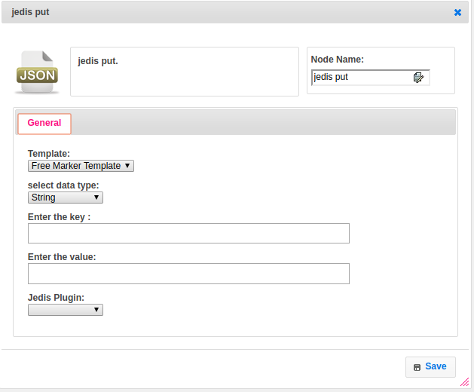

**Executor Description:**

In executor class first it will connect to redis server by using Redis Plugin Handler based on host and port values and Execute the respective jedis client method to store the data based on type of data provided, For each data type have respective methods to store data. But as of write now we are supporting String data type only.